# Exercise 1(B) - Additional Task 1

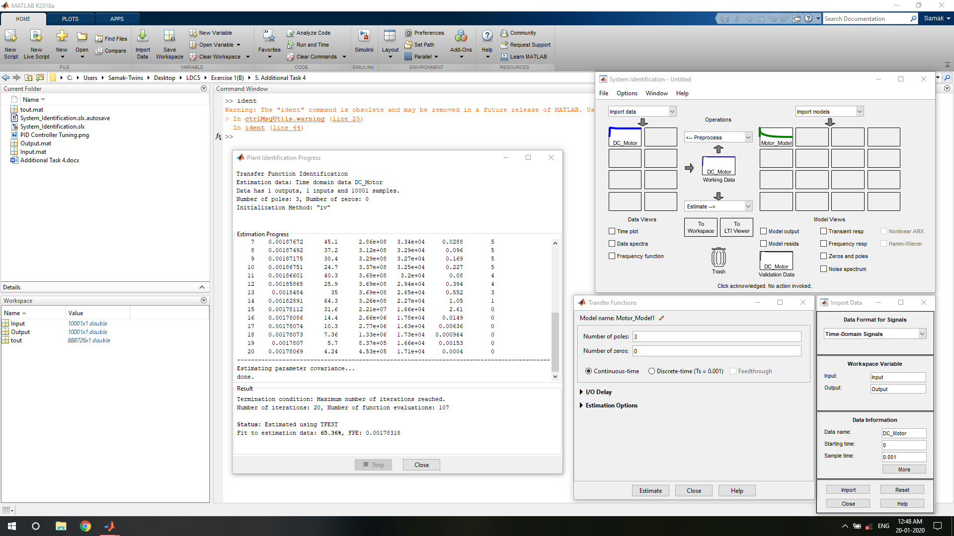

The system identification toolbox provided in MATLAB (SIMULINK) was studied and used for system identification procedures.

Additional Task 4 of this exercise was also accomplished with the use of the system identification toolbox provided in MATLAB (SIMULINK).